CS 5970/6970: Graph Algorithms
September 1, 2023
Homework 2
Question 1. Without path compression, what is the runtime of the union and find operation? (10 points)
Without path compression the runtime of the operations union and find are both O(n).
Question 2. Draw out the tree structure and array values (for that type of implementation) of disjointset/union-find without path compression after the following operations. (10 points) makeset(A..L) (shorthand for running on each node A to L)
Union(C,K)
Union(F,E)
Union(A,J)
Union(A,B)
Union(C,D)
Union(D,I)
Union(L,F)
Union(C,A)
Union(A,B)
Union(H,G)
nodes | A | B | C | D | E | F | G | H | I | J | K | L
index | 0 | 1 | 2 | 3 | 4 | 5 | 6 | 7 | 8 | 9 | 10 | 11
value | 2 | 0 | 2 | 2 | 5 | 11 | 7 | 7 | 2 | 0 | 2 | 7
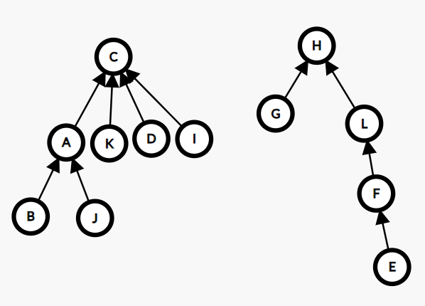
Union(H,F)

nodes | A | B | C | D | E | F | G | H | I | J | K | L
index | 0 | 1 | 2 | 3 | 4 | 5 | 6 | 7 | 8 | 9 | 10 | 11
value | 2 | 2 | 2 | 2 | 5 | 7 | 7 | 7 | 2 | 0 | 2 | 7
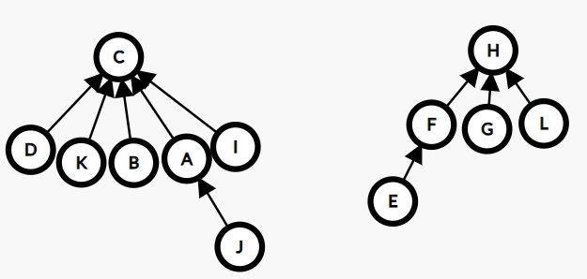
Question 3. Do the same with path compression. (10 points)
 | Push | Extract-Min | Decrease Key
Linked List | O(1) | O(n) | O(1)
Binary Heap | O(log n) | O(log n) | O(log n)
Binomial Heap | O(1) amortized | O(log n) | O(log n)
Fibonacci Heap | O(1) | O(log n) amortized | O(1)
Question 4. What abstract data structure does Prim’s algorithm use and name at least two implementations of that abstract data structure. (10 points)
Prim’s algorithm uses a priority queue which can be implemented with a linked list, binary heap, binomial heap, and Fibonacci heap. Below is a table of the different asymptotic notations for the functions push, extract-min, and decrease key.
Question 5. Implement the DisjointSet class in homework2.py with path compression. (30 points)
See homework2.py

Question 6. Implement Kruskal’s algorithm using your union-find/disjoint set functions and draw the minimum spanning tree using networkx. (30 points)
See homework2.py

